Nama : Mar’atus Shalihah

Nim : 200209500018

Kelas : PTIK C

**Tugas 4**

1. Download tugas.m dalam elearning dan jalankan programnya di Matlab. (tujuannya membuat isi matrix yang akan dikerjakan tidak ada yang sama)
2. Gunakan karnel filter lowpass untuk dikonvolusikan ke isi variabel c.
3. Kerjakan di word dengan menuliskan isi matrik C dan proses pengerajaannya hingga menghasilkan matrix hasil konvolusi dengan isi variabel c.
4. Simpan file word tersebut beserta file *.mat ( nama _depanmu.mat) kedalam satu file *.rar lalu diupload ke Elearning.

**Jawaban :**

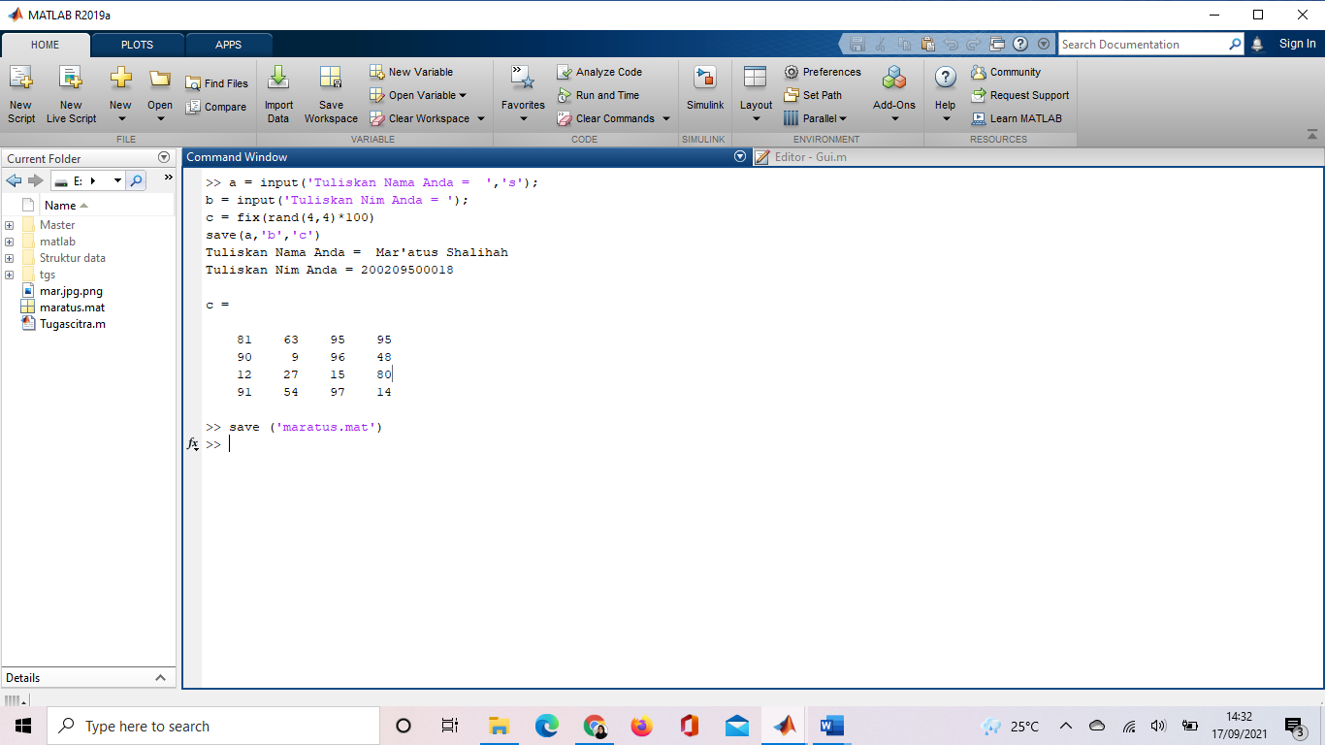

Matriks : Karnel LowPass

|  |  |  |
| --- | --- | --- |
| 1/12 | 1/12 | 1/12 |
| 1/12 | 1/12 | 1/12 |
| 1/12 | 1/12 | 1/12 |

|  |  |  |
| --- | --- | --- |
| 1/12 | 1/12 | 1/12 |
| 1/12 | 4/12  x 81 | 1/12  x 63 | 95 | 95 |
| 1/12 | 1/12  x 90 | 1/12  x 9 | 96 | 48 |
| 12 | 27 | 15 | 80 |
| 91 | 54 | 97 | 14 |

Cara Kerja :

|  |  |  |  |
| --- | --- | --- | --- |
| 81 | 63 | 95 | 95 |
| 90 | 9 | 96 | 48 |
| 12 | 27 | 15 | 80 |
| 91 | 54 | 97 | 14 |

* Konvolusinya : (4x81 + 1x 63 +1x90 + 1x 9) /12 = 40

|  |  |  |  |
| --- | --- | --- | --- |
| 81 | 63 | 95 | 95 |
| 90 | 9 | 96 | 48 |
| 12 | 27 | 15 | 80 |
| 91 | 54 | 97 | 14 |

|  |  |  |
| --- | --- | --- |
| 1/12 | 1/12 | 1/12 |
| 1/12 x 81 | 4/12 x 63 | 1/12 x 95 | 95 |
| 90 | 9 | 96 | 48 |
| 12 | 27 | 15 | 80 |
| 91 | 54 | 97 | 14 |

* Konnvolusinya : ( 1 x 81 + 4 x 63 + 1 x 95 + 1 x 90 + 1 x 9 + 1 x 96) / 12 = 52

|  |  |  |  |
| --- | --- | --- | --- |
| 81 | 63 | 95 | 95 |
| 90 | 9 | 96 | 48 |
| 12 | 27 | 15 | 80 |
| 91 | 54 | 97 | 14 |

|  |  |  |  |  |
| --- | --- | --- | --- | --- |
| 1/12 | 1/12 | 1/12 | | |
| 81 | 1/12 x 63 | 4/12 x 95 | | 1/12 x 95 |
| 90 | 1/12 x 9 | 1/12 x 96 | | 1/12 x 48 |
| 12 | 27 | 15 | | 80 |
| 91 | 54 | 97 | | 14 |

* Konvolusinya : (1 x 63 + 4 x 95 + 1 x 95 + 1 x 9 + 1 x 96 + 1 x 48 ) / 12 = 58

|  |  |  |  |
| --- | --- | --- | --- |
| 81 | 63 | 95 | 95 |
| 90 | 9 | 96 | 48 |
| 12 | 27 | 15 | 80 |
| 91 | 54 | 97 | 14 |

|  |  |  |
| --- | --- | --- |
| 1/12 | 1/12 | 1/12 |
| 81 | 63 | 1/12 x 95 | 4/12 x 95 | 1/12 |
| 90 | 9 | 1/12 x 96 | 1/12 x 48 | 1/12 |
| 12 | 27 | 15 | 80 |
| 91 | 54 | 97 | 14 |

* Konvulusinya : (1 x 95 + 4 x 95 + 1 x 96 + 1 x 48 ) / 12 = 52

|  |  |  |  |
| --- | --- | --- | --- |
| 81 | 63 | 95 | 95 |
| 90 | 9 | 96 | 48 |
| 12 | 27 | 15 | 80 |
| 91 | 54 | 97 | 14 |

|  |  |  |  |  |
| --- | --- | --- | --- | --- |
| 1/12 | 1/12 x 81 | 1/12 x 63 | 95 | 95 |
| 1/12 | 4/12 x 90 | 1/12 x 9 | 96 | 48 |
| 1/12 | 1/12 x 12 | 1/12 x 27 | 15 | 80 |
| 91 | 54 | 97 | 14 |

* Konvolusinya : ( 1 x 81 + 1 x 63 + 4 x 90 + 1 x 9 + 1 x 12 + 1 x 27 ) / 12 = 46

|  |  |  |  |
| --- | --- | --- | --- |
| 81 | 63 | 95 | 95 |
| 90 | 9 | 96 | 48 |
| 12 | 27 | 15 | 80 |
| 91 | 54 | 97 | 14 |

|  |  |  |  |
| --- | --- | --- | --- |
| 1/12 x 81 | 1/ 12 x 63 | 1/12 x 95 | 95 |
| 1/12 x 90 | 4/12 x 9 | 1/12 x 96 | 48 |
| 1/12 x 12 | 1/12 x 27 | 1/12 x 15 | 80 |
| 91 | 54 | 97 | 14 |

* Konvolusinya : ( 1 x 81 + 1 x 63 + 1 x 95 + 1 x 90 + 4 x 9 + 1 x 96 + 1 x 12 + 1 x 27 + 1 x 15 ) / 12 = 43

|  |  |  |  |
| --- | --- | --- | --- |
| 81 | 63 | 95 | 95 |
| 90 | 9 | 96 | 48 |
| 12 | 27 | 15 | 80 |
| 91 | 54 | 97 | 14 |

|  |  |  |  |
| --- | --- | --- | --- |
| 81 | 1/12 x 63 | 1/12 x 95 | 1/12 x 95 |
| 90 | 1/12 x 9 | 4/12 x 96 | 1/12 x 48 |
| 12 | 1/12 x 27 | 1/12 x 15 | 1/12 x 80 |
| 91 | 54 | 97 | 14 |

* Konvolusinya : ( 1 x 63 + 1 x 95 + 1 x 95 + 1 x 9 + 4 x 96 + 1 x 48 + 1 x 27 + 1 x 15 + 1 x 80) / 12 = 68

|  |  |  |  |
| --- | --- | --- | --- |
| 81 | 63 | 95 | 95 |
| 90 | 9 | 96 | 48 |
| 12 | 27 | 15 | 80 |
| 91 | 54 | 97 | 14 |

|  |  |  |  |  |
| --- | --- | --- | --- | --- |
| 81 | 63 | 1/12 x 95 | 1/12 x 95 | 1/12 |
| 90 | 9 | 1/12 x 96 | 4/12 x 48 | 1/12 |
| 12 | 27 | 1/12 x 15 | 1/12 x 80 | 1/12 |
| 91 | 54 | 97 | 14 |

* Konvolusinya : ( 1 x 95 + 1 x 95 + 1 x 96 + 4 x 48 + 1 x 15 + 1 x 80) / 12 = 48

|  |  |  |  |
| --- | --- | --- | --- |
| 81 | 63 | 95 | 95 |
| 90 | 9 | 96 | 48 |
| 12 | 27 | 15 | 80 |
| 91 | 54 | 97 | 14 |

|  |  |  |  |
| --- | --- | --- | --- |
| 81 | 63 | 95 | 95 |
| 1/12 | 1/12 x 90 | 1/12 x 9 | 96 | 48 |
| 1/12 | 4/12 x 12 | 1/12 x 27 | 15 | 80 |
| 1/12 | 1/12 x 91 | 1/12 x 54 | 97 | 14 |

* Konvolusinya : (1 x 90 + 1 x 9 + 4 x 12 + 1 x 27 + 1 x 91 + 1 x 54 ) / 12 = 27

|  |  |  |  |
| --- | --- | --- | --- |
| 81 | 63 | 95 | 95 |
| 1/12 x 90 | 1/12 x 9 | 1/12 x 96 | 48 |
| 1/12 x 12 | 4/12 x 27 | 1/12 x 15 | 80 |
| 1/12 x 91 | 1/12 x 54 | 1/12 x 97 | 14 |

|  |  |  |  |
| --- | --- | --- | --- |
| 81 | 63 | 95 | 95 |
| 90 | 9 | 96 | 48 |
| 12 | 27 | 15 | 80 |
| 91 | 54 | 97 | 14 |

* Konvolusinya : (1 x 90 + 1 x 9 + 1 x 96 + 1 x 12 + 4 x 27 + 1 x 15 + 1 x 91 + 1 x 54 + 1 x 97 ) / 12 = 48

|  |  |  |  |
| --- | --- | --- | --- |
| 81 | 63 | 95 | 95 |
| 90 | 9 | 96 | 48 |
| 12 | 27 | 15 | 80 |
| 91 | 54 | 97 | 14 |

|  |  |  |  |
| --- | --- | --- | --- |
| 81 | 63 | 95 | 95 |
| 90 | 1/12 x 9 | 1/12 x 96 | 1/12 x 48 |
| 12 | 1/12 x 27 | 4/12 x 15 | 1/12 x 80 |
| 91 | 1/12 x 54 | 1/12 x 97 | 1/12 x 14 |

* Konvolusinya : ( 1 x 9 + 1 x 96 + 1 x 48 + 1 x 27 + 4 x 15 + 1 x 80 + 1 x 54 + 1 x 97 + 1 x 14 ) / 12 = 40

|  |  |  |  |
| --- | --- | --- | --- |
| 81 | 63 | 95 | 95 |
| 90 | 9 | 96 | 48 |
| 12 | 27 | 15 | 80 |
| 91 | 54 | 97 | 14 |

|  |  |  |  |
| --- | --- | --- | --- |
| 81 | 63 | 95 | 95 |
| 90 | 9 | 1/12 x 96 | 1/12 x 48 | 1/12 |
| 12 | 27 | 1/12 x 15 | 4/12 x 80 | 1/12 |
| 91 | 54 | 1/12 x 97 | 1/12 x 14 | 1/12 |

* Konvolusinya : ( 1 x 96 + 1 x 48 + 1 x 15 + 4 x 80 + 1 x 97 + 1 x 14) / 12 = 49

|  |  |  |  |
| --- | --- | --- | --- |
| 81 | 63 | 95 | 95 |
| 90 | 9 | 96 | 48 |
| 12 | 27 | 15 | 80 |
| 91 | 54 | 97 | 14 |

|  |  |  |  |
| --- | --- | --- | --- |
| 81 | 63 | 95 | 95 |
| 90 | 9 | 96 | 48 |
| 1/12 | 1/12 x 12 | 1/12 x 27 | 15 | 80 |
| 1/12 | 4/12 x 91 | 1/12 x 54 | 97 | 14 |
| 1/12 | 1/12 | 1/12 |

* Konvolusinya : ( 1 x 12 + 1 x 27 + 4 x 91 + 1 x 54 ) / 12 = 38

|  |  |  |  |
| --- | --- | --- | --- |
| 81 | 63 | 95 | 95 |
| 90 | 9 | 96 | 48 |
| 12 | 27 | 15 | 80 |
| 91 | 54 | 97 | 14 |

|  |  |  |  |
| --- | --- | --- | --- |
| 81 | 63 | 95 | 95 |
| 90 | 9 | 96 | 48 |
| 1/12 x 12 | 1/12 x 27 | 1/12 x 15 | 80 |
| 1/12 x 91 | 4/12 x 54 | 1/12 x 97 | 14 |
| 1/12 | 1/12 | 1/12 |

* Konvolusinya : ( 1 x 12 + 1 x 27 + 1 x 15 + 1 x 91 + 4 x 54 + 1 x 97 ) /12 = 38

|  |  |  |  |
| --- | --- | --- | --- |
| 81 | 63 | 95 | 95 |
| 90 | 9 | 96 | 48 |
| 12 | 27 | 15 | 80 |
| 91 | 54 | 97 | 14 |

|  |  |  |  |
| --- | --- | --- | --- |
| 81 | 63 | 95 | 95 |
| 90 | 9 | 96 | 48 |
| 12 | 1/12 x 27 | 1/12 x 15 | 1/12 x 80 |
| 91 | 1/12 x 54 | 4/12 x 97 | 1/12 x 14 |
| 1/12 | 1/12 | 1/12 |

* Konvolusinya : ( 1 x 27 + 1 x 15 + 1 x 80 + 1 x 54 + 4 x 97 + 1 x 14 ) / 12 = 48

|  |  |  |  |
| --- | --- | --- | --- |
| 81 | 63 | 95 | 95 |
| 90 | 9 | 96 | 48 |
| 12 | 27 | 15 | 80 |
| 91 | 54 | 97 | 14 |

|  |  |  |  |
| --- | --- | --- | --- |
| 81 | 63 | 95 | 95 |
| 90 | 9 | 96 | 48 |
| 12 | 27 | 1/12 x 15 | 1/12 x 80 | 1/12 |
| 91 | 54 | 1/12 x 97 | 4/12 x 14 | 1/12 |
| 1/12 | 1/12 | 1/12 |

* Konvolusinya : ( 1 x 15 + 1 x 80 + 1 x 97 + 4 x 14 ) / 12 = 21

**HASIL :**

|  |  |  |  |
| --- | --- | --- | --- |
| 40 | 52 | 58 | 52 |
| 46 | 43 | 68 | 48 |
| 27 | 48 | 40 | 49 |
| 38 | 38 | 48 | 21 |